VSAM – VIRTUAL STORAGE ACCESS METHOD
WHAT IS VSAM?
VSAM is a DASD file management system used in MVS Z(OS). Using VSAM, we can organize records in physical sequence (the sequential order in which they are entered), logical sequence using a key (Ex:- Emp #) or by the relative record number.

BENEFITS
VSAM files (or) datasets can be used via DD statements in JCL Batch (TSO) as well as in Online (CICS region) while Physical sequential files can be used only in Batch (TSO). VSAM files are highly secured (password protection) and stable (Dedicated protected DASD volumes). Records in VSAM are accessed faster when compared to Sequential files

TYPES OF VSAM DATASETS
There are 4 types of VSAM Datasets:-
- Entry Sequenced Data Set (ESDS)
- Key Sequenced Data Set (KSDS)
- Relative Record Data Set (RRDS)
- Linear Data Set (LDS)

DATA STORAGE
Data in a VSAM file can be of fixed length or variable length (used very rarely). They are organized within DASD in fixed size blocks called Control Intervals (CIs) and then into larger division called Control Areas (CAs). Cis are usually given in KB and while CAs are given in TRK/CYL. Control Intervals are the unit of transfer between an application program (say COBOL) while reading records from a VSAM file. There will be fixed number of Cis in a CA. There will be many CAs in a DASD TRK/CYL. The way in which it is stored is not visible to application programmer but we need to know understand this.

DASD (1 CYL)
CONTROL AREA (CA)
CONTROL AREA (CA)
43 | 44 | 45 | 46 | 47 | 48
49 | 50 | 51 | 52 | 53 | 54
55 | 56 | 57 | 58 | 59 | 60
61 | 62 | 63 | 64 | 65 | 66
67 | 68 | 69 | 70 | 71 | 72
73 | 74 | 75 | 76 | 77 | 78
79 | 80 | 81 | 82 | 83 | 84
1 | 2 | 3 | 4 | 5 | 6
7 | 8 | 9 | 10 | 11 | 12
13 | 14 | 15 | 16 | 17 | 18
19 | 20 | 21 | 22 | 23 | 24
25 | 26 | 27 | 28 | 29 | 30
31 | 32 | 33 | 34 | 35 | 36
37 | 38 | 39 | 40 | 41 | 42
Control Intervals

Free space
CONTROL AREA (CA)

Control Interval
1 | 2 | 3 | 4 | 5 | 6 | RDF | CIDF
Index Set

Pointer | 84 | 42
Sequence Set

Pointer | 42 | 36 | 30 | 24 | 18 | 12 | 6

RDF – Record Definition Field. It’s a 3 byte field and denotes the number of records with the same length in the Control Interval. For Fixed length records, we would have only one RIDF per CI.
CIDF – Control Interval Definition Field. It’s a 4 byte field and contains information about CI.
INDEX SET – Index Set will contain all the last keys of a Control Area
SEQUENCE SET - There will be one sequence set per CA. It will have the key of last record.
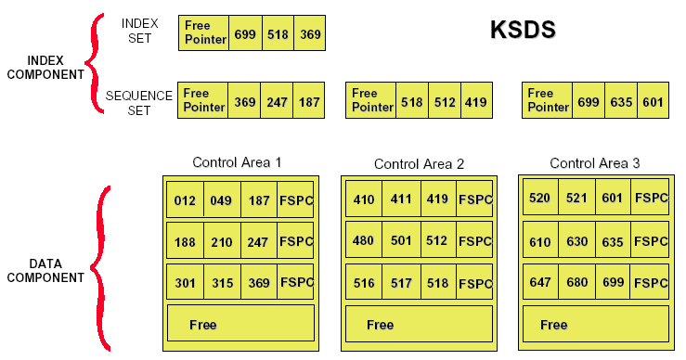

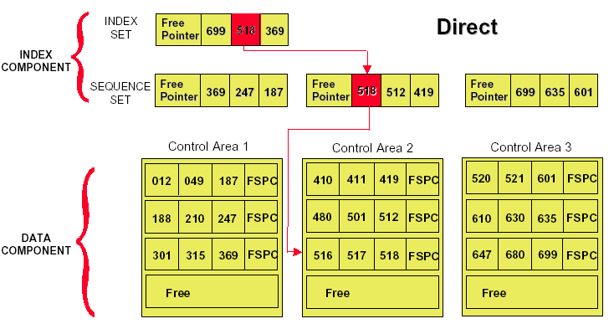

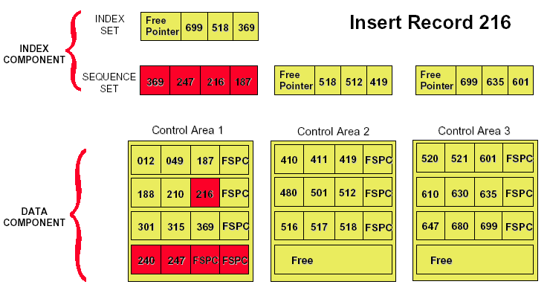
ESDS:
This file is similar to a Physical Sequential file. Records are stored into ESDS in the order we write thru IDCAMS utility or a program. There is no index for a ESDS file. Only Sequential processing is usually done while random processing can be done with the use of RBA (Relative Byte Address).
KSDS:
A KSDS stands for Key sequenced Dataset. It is the most widely used VSAM dataset. It can have a key and hence we could do both sequential and random processing of records with the use of VSAM. Records are written with either IDCAMS or thru a Program (Batch/Online).
A KSDS dataset is called a cluster. It will have a data as well as an Index component. Data component will contain the actual data while index component will have Key and the corresponding address of record in data component. In JCLs, the cluster is used in DDNAME so that both data and index components are available for the utility/program.
Alternate Indexes (Secondary Indexes) can be created for a KSDS cluster.
RRDS:
Records are written to a RRDS file thru IDCAMS utility/Program in a relative sequence with which it is entered. Each record has a relative record number which starts from 1 for the first record, 2 for the second record and goes on sequentially. Both sequential and random processing are done using RRDS.

LDS:
LDS is an unstructured VSAM dataset and simply contains memory and used only to stored DB2 databases. It is not used for any application programming.

DEFINING/DELETING VSAM DATASETS
IDCAMS utility is used to DEFINE a VSAM file, ALTER its characters, LOAD and DELETE.

ESDS CLUSTER:
|----|----|----|----|----|----|----|----|----|----|----|----|----|----
//HLQJ JOB ABC,CLASS=A,NOTIFY=&SYSUID
//*
//*JCL TO DEFINE A VSAM ESDS DATASET
//*
//STEP0001 DD PGM=IDCAMS
//*
//SYSPRINT DD SYSOUT=*
//SYSIN DD *
DEFINE CLUSTER (NAME(HLQ.VSAM.ESDSFILE) –
NONINDEXED - (Denotes No Unique Key is Present)
RECSZ(80 80) - (Min Rec Size Max Rec Size)
TRACKS(1,1) - (Primary Qty Secondary Qty)
CISZ(4096) - (Control Interval Size in Bytes)
DATA(NAME(HLQ.VSAM.ESDSFILE.DATA))
/*
//*

Once you execute the above step, it will be a MAXCC=0 (Maxx cond code) and create a ESDS VSAM cluster.

When you go to 3.4, you will see the following entries:-
HLQ.VSAM.ESDSFILE
HLQ.VSAM.ESDSFILE.DATA

In Utilities or Programs, we give the cluster name WPRXXX.VSAM.ESDSFILE to refer to this file. Once created, it could not be recreated unless it is deleted.

//HLQJ JOB ABC,CLASS=A,NOTIFY=&SYSUID
//*
//*JCL TO DELETE A VSAM ESDS DATASET
//*
//STEP0001 DD PGM=IDCAMS
//*
//SYSPRINT DD SYSOUT=*
//SYSIN DD *
DELETE HLQ.VSAM.ESDSFILE CLUSTER PURGE
/*

KSDS CLUSTER:
|----|----|----|----|----|----|----|----|----|----|----|----|----|----
//HLQJ JOB ABC,CLASS=A,NOTIFY=&SYSUID
//*
//*JCL TO DEFINE A VSAM KSDS DATASET
//*
//STEP0001 DD PGM=IDCAMS
//*
//SYSPRINT DD SYSOUT=*
//SYSIN DD *
DEFINE CLUSTER (NAME(HLQ.VSAM.KSDSFILE) –
INDEXED - (Presence of Key)
KEYS(6 0) - (Length of Key Offset)
RECSZ(80 80) - (Min Record Size Max Record Size)
TRACKS(1,1) - (Primary Qty Secondary Qty)
CISZ(4096) - (Size of Control Interval in Bytes)
REUSE - (Reuse denotes file can be reloaded)
FREESPACE(5 5)) – (CI Free space CA Free space)
DATA(NAME(HLQ.VSAM.KSDSFILE.DATA) CISZ(4096)) -
INDEX(NAME(HLQ.VSAM.KSDSFILE.INDEX) CISZ(4096))

/*
//*
Once you execute the above step, it will be a MAXCC=0 (Maxx cond code) and create a ESDS VSAM cluster.

When you go to 3.4, you will see the following entries:-
HLQ.VSAM.KSDSFILE
HLQ.VSAM.KSDSFILE.DATA
HLQ.VSAM.KSDSFILE.INDEX

In Utilities or Programs, we give the cluster name WPRXXX.VSAM.KSDSFILE to refer to this file. Once created, it could not be recreated unless it is deleted.

//HLQJ JOB ABC,CLASS=A,NOTIFY=&SYSUID
//*
//*JCL TO DELETE A VSAM ESDS DATASET
//*
//STEP0001 DD PGM=IDCAMS
//*
//SYSPRINT DD SYSOUT=*
//SYSIN DD *
DELETE HLQ.VSAM.KSDSFILE CLUSTER PURGE
/*

RRDS CLUSTER:
|----|----|----|----|----|----|----|----|----|----|----|----|----|----
//HLQJ JOB ABC,CLASS=A,NOTIFY=&SYSUID
//*
//*JCL TO DEFINE A VSAM RRDS DATASET
//*
//STEP0001 DD PGM=IDCAMS
//*
//SYSPRINT DD SYSOUT=*
//SYSIN DD *
DEFINE CLUSTER (NAME(HLQ.VSAM.RRDSFILE) –
NUMBERED - (Denotes RRDS)
RECSZ(80 80) -
TRACKS(1,1) -
CISZ(4096) -
FREESPACE(5 5)) -
DATA(NAME(HLQ.VSAM.RRDSFILE.DATA))
/*
//*

Once you execute the above step, it will be a MAXCC=0 (Maxx cond code) and create a ESDS VSAM cluster.

When you go to 3.4, you will see the following entries:-
HLQ.VSAM.RRDSFILE
HLQ.VSAM.RRDSFILE.DATA

In Utilities or Programs, we give the cluster name WPRXXX.VSAM.KSDSFILE to refer to this file. Once created, it could not be recreated unless it is deleted.

//HLQJ JOB ABC,CLASS=A,NOTIFY=&SYSUID
//*
//*JCL TO DELETE A VSAM RRDS DATASET
//*
//STEP0001 DD PGM=IDCAMS
//*
//SYSPRINT DD SYSOUT=*
//SYSIN DD *
DELETE HLQ.VSAM.RRDSFILE CLUSTER PURGE
/*
//*

LOADING A VSAM DATASET

REPRO Command in IDCAMS can used to load a VSAM dataset for initial processing. Using IDCAMS – REPRO, we could load a VSAM file from a Sequential file and vice versa.

REPRO COMMAND SYNTAX
REPRO {INFILE(<INPUT-FILE-DDNAME>) –
OR
INDATASET(INPUT FILE DATASET NAME)} -

{OUTFILE(<OUTPUT-FILE-DDNAME) –
OR
INDATASET(INPUT FILE DATASET NAME)} –

SKIP(COUNT OF RECS TO BE SKIPPED FROM INPUT FILE) –
COUNT(NUMBER OF RECS TO BE COPIED TO OUTPUT FILE) –
{FROMKEY(KEY VALUE) (OR) FROMADDRESS (RELATIVE BYTE ADDRESS)
(OR) FROMNUMBER(RELATIVE RECORD NUMBER)} –

{TOKEY(KEY VALUE) (OR) TOADDRESS (RELATIVE BYTE ADDRESS)
(OR) TONUMBER(RELATIVE RECORD NUMBER)} –
REUSE/NOREUSE -
REPLACE/NOREPLACE

Load a Sequential file to a VSAM cluster:

//HLQJ JOB ABC,CLASS=A,NOTIFY=&SYSUID
//*
//*JCL TO DELETE A VSAM RRDS DATASET
//*
//STEP0001 EXEC PGM=IDCAMS
//INPUT DD DSN=HLQ.VSAM.INPUT,DISP=SHR
//*
//OUTPUT DD DSN=HLQ.VSAM.ESDSFILE,DISP=OLD
//SYSPRINT DD SYSOUT=*
//SYSIN DD *
REPRO INFILE(INPUT) OUTFILE(OUTPUT)
/*
//*

Load a Sequential file to a Reusable VSAM cluster (That was earlier defined with REUSE):

//HLQJ JOB ABC,CLASS=A,NOTIFY=&SYSUID
//*
//*JCL TO DELETE A VSAM RRDS DATASET
//*
//STEP0001 EXEC PGM=IDCAMS
//INPUT DD DSN=HLQ.VSAM.INPUT,DISP=SHR
//*
//OUTPUT DD DSN=HLQ.VSAM.ESDSFILE,DISP=OLD
//SYSPRINT DD SYSOUT=*
//SYSIN DD *
REPRO INFILE(INPUT) OUTFILE(OUTPUT) REUSE
/*
//*

Replace Output Keyed records or Insert new records from a Physical Sequential file to a VSAM cluster
//HLQJ JOB ABC,CLASS=A,NOTIFY=&SYSUID
//*
//*JCL TO DELETE A VSAM RRDS DATASET
//*
//STEP0001 EXEC PGM=IDCAMS
//INPUT DD DSN=HLQ.VSAM.INPUT,DISP=SHR
//*
//OUTPUT DD DSN=HLQ.VSAM.ESDSFILE,DISP=OLD
//SYSPRINT DD SYSOUT=*
//SYSIN DD *
REPRO INFILE(INPUT) OUTFILE(OUTPUT) REPLACE
/*
//*

Copy a VSAM file to a Seq file:
//HLQJ JOB ABC,CLASS=A,NOTIFY=&SYSUID
//*
//*JCL TO DELETE A VSAM RRDS DATASET
//*
//STEP0001 EXEC PGM=IDCAMS
//INPUT DD DSN=HLQ.VSAM.ESDSFILE,DISP=SHR
//*
//OUTPUT DD DSN=HLQ.VSAM.OUTPUT.SEQ.BKUP,
// DISP=(NEW,CATLG,DELETE),
// DCB=(LRECL=80,BLKSIZE=800,RECFM=FB),
// SPACE=(TRK,(1,1),RLSE)
//SYSPRINT DD SYSOUT=*
//SYSIN DD *
REPRO INFILE(INPUT) OUTFILE(OUTPUT)
/*
//*

Copy first 1000 Records from a VSAM file to a Seq file:
//HLQJ JOB ABC,CLASS=A,NOTIFY=&SYSUID
//*
//*JCL TO DELETE A VSAM RRDS DATASET
//*
//STEP0001 EXEC PGM=IDCAMS
//INPUT DD DSN=HLQ.VSAM.ESDSFILE,DISP=SHR
//*
//OUTPUT DD DSN=HLQ.VSAM.OUTPUT.SEQ.BKUP,
// DISP=(NEW,CATLG,DELETE),
// DCB=(LRECL=80,BLKSIZE=800,RECFM=FB),
// SPACE=(TRK,(1,1),RLSE)
//SYSPRINT DD SYSOUT=*
//SYSIN DD *
REPRO INFILE(INPUT) OUTFILE(OUTPUT) COUNT(1000)
/*
//*

Copy a selective Keyed records from a VSAM file to a Seq file:
//HLQJ JOB ABC,CLASS=A,NOTIFY=&SYSUID
//*
//*JCL TO DELETE A VSAM RRDS DATASET
//*
//STEP0001 EXEC PGM=IDCAMS
//INPUT DD DSN=HLQ.VSAM.ESDSFILE,DISP=SHR
//*
//OUTPUT DD DSN=HLQ.VSAM.OUTPUT.SEQ.BKUP,
// DISP=(NEW,CATLG,DELETE),
// DCB=(LRECL=80,BLKSIZE=800,RECFM=FB),
// SPACE=(TRK,(1,1),RLSE)
//SYSPRINT DD SYSOUT=*
//SYSIN DD *
REPRO INFILE(INPUT) OUTFILE(OUTPUT) FROMKEY(10001) TOKEY(30000)
/*
//*

PRINT COMMAND SYNTAX
Display the contents of the Input file. You may also add FROMKEY, FROMADDRESS, FROMNUMBER, SKIP and COUNT
//STEP0001 EXEC PGM=IDCAMS
//INPUT DD DSN=HLQ.VSAM.ESDSFILE,DISP=SHR
//*
//SYSPRINT DD SYSOUT=*
//SYSIN DD *
PRINT INFILE(INPUT) CHAR
/*
//*

VERIFY COMMAND SYNTAX
Verify Command is to close an Improperly closed VSAM file due to user error or a Job failed error

//STEP0001 EXEC PGM=IDCAMS
//*
//SYSPRINT DD SYSOUT=*
//SYSIN DD *
VERIFY DS(HLQ.VSAM.KSDSFILE)
/*
//*

LISTCAT ENTRIES
List the catalog entries of a VSAM cluster. This is used to monitor the activity of a file.

//STEP0001 EXEC PGM=IDCAMS
//SYSPRINT DD SYSOUT=*
//SYSIN DD *
LISTCAT ENTRIES(HLQ.VSAM.KSDSFILE) ALL CHAR
/*
//*

ALTER VSAM CLUSTER
Alter is used to change the logical characteristics (such as CISZ, FREESPACE) of a VSAM dataset. The Physical characteristics (RECSZ, ) cannot be changed using an ALTER command however cluster name could be changed using this command.

//STEP0001 EXEC PGM=IDCAMS
//SYSPRINT DD SYSOUT=*
//SYSIN DD *
ALTER HLQ.VSAM.KSDSFILE FREESPACE(15 15) CISZ(1024)
/*
//*

DELETE VSAM CLUSTER
Delete is used to physically delete the VSAM cluster. Once the cluster is deleted, all of its associated entries like an Alternate Index, Path will also be deleted automatically.

//STEP0001 EXEC PGM=IDCAMS
//SYSPRINT DD SYSOUT=*
//SYSIN DD *
DELETE (HLQ.VSAM.KSDSFILE) PURGE FORCE
/*
//*

ALTERNATE INDEXES (For KSDS)
In Online Programs, there is highly likely that a secondary search field is required. In this case, to improve performance of data retrieval, we create a secondary index file with this unique or non-unique search field and use it Online. Given below are the steps involved in creating the alternate Index.

1. Define the base cluster, using the DEFINE CLUSTER command thru IDCAMS
2. Load the base cluster either by using the REPRO command or by writing your own program to load the data set.
3. Define the alternate index, using the DEFINE ALTERNATEINDEX command.
4. Relate the alternate index to the base cluster, using the DEFINE PATH command.
5. Build the alternate index, using the BLDINDEX command.

DEFINE ALTERNATE INDEX AND PATH – Alternate Index can have the same minimum record length of that of the Base cluster except the record keys are different, UPGRADE keyword denotes that the AIX and PATH will upgrade (upadate) automatically when the Base cluster undergoes changes. Path denotes the relationship between an Alternate Index file and a Base cluster. Default is NOUPGRADE. In this case, we need to periodically Build the Alternater Index such that BASE cluster, AIX cluster and PATH all are in sync (Have same data). REUSE is not allowed for a KSDS cluster if it has AIX.

//STEP1 EXEC PGM=IDCAMS
//SYSPRINT DD SYSOUT=*
//SYSIN DD *
DEFINE ALTERNATEINDEX -
(NAME(HLQ.KSDS.AIX) -
RELATE(WPRAA.KSDS.FILE) -
KEYS(20 7) -
RECORDSIZE(80 250) -
TRACKS(1 1) -
NONUNIQUEKEY -
UPGRADE) -
DATA(NAME(HLQ.KSDS.AIX.DATA)) –
INDEX(NAME(HLQ.KSDS.AIX.INDEX))
/*

Max Record Size = Sec Key length + (N * Primary key Length) + 5
5 – RDF/CIDF
N – No of expected duplicates

DEFINES THE PATH THRU WHICH RECORDS ARE UPDATED IN AIX FROM BASE CLUSTER
//STEP1 EXEC PGM=IDCAMS
//SYSPRINT DD SYSOUT=*
//SYSIN DD *
DEFINE PATH -
(NAME(HLQ.KSDS.AIX.PATH) -
PATHENTRY(HLQ.KSDS.AIX) -
UPDATE
/*

LOADS THE AIX CLUSTER FROM THE BASE CLUSTER FOR THE FIRST TIME
//STEP2 EXEC PGM=IDCAMS
//SYSPRINT DD SYSOUT=*
//INPUT DD DSN=HLQ.KSDS.FILE,DISP=SHR
//OUTPUT DD DSN=HLQ.KSDS.AIX,DISP=SHR
//SYSIN DD *
BLDINDEX INFILE(INPUT) -
OUTFILE(OUTPUT)
/*

Incase if you want to use AIX in a COBOL program, In the SELECT clause, we need to mention ALTERNATE RECORD KEY IS clause after RECORD KEY

SELECT VSAM-KSDS-FILE ASSIGN TO UT-VSAMKSDS
ORGANIZATION IS INDEZED
ACCESS IS DYNAMIC
RECORD KEY IS VSAM-REC-KEY
ALTERNATE RECORD KEY IS VSAM-ALT-REC-KEY
WITH DUPLICATES
FILE STATUS IS VSAM-FILE-STATUS.

Mention appropriately the position and length in FD entries (Example only)

FD VSAM-KSDS-FILE
RECORD CONTAINS 100 CHARACTERS.
01 VSAM-REC-KEY PIC X(10).
01 VSAM-ALT-REC-KEY PIC X(20).
01 FILLER PIC X(70).

In Program Populate VSAM-ALT-REC-KEY and you can use a START, READ NEXT etc. Program will refer to the PATH and not the BASE cluster.

In JCL, we need to add the PATH file as given below:-

//VSAMKSDS DD DSN=HLQ.VSAM.KSDSFILE,DISP=SHR
//VSAMKSD1 DD DSN=HLQ.VSAM.KSDSFILE.AIX.PATH,DISP=SHR

(A DD Name is added in JCL for PATH with the same ddname as BASE cluster, except the last character is changed to 1, Also no select clause is required in COBOL program for this DD name)

In IDCAMS, REPRO, if an empty I/p file is given, IDCAMS will run successfully with a Return code of 4. This way it is used whether a file is empty thru JCL.

